**JOYSTICK WITH ARDUINO**

Introduction

The Analog Joystick is similar to two potentiometers connected together, one for the vertical movement (Y-axis) and other for the horizontal movement (X-axis). The joystick also comes with a Select switch.

A **joystick** is an [input device](https://en.wikipedia.org/wiki/Input_device) consisting of a stick that pivots on a base and reports its angle or direction to the device it is controlling.

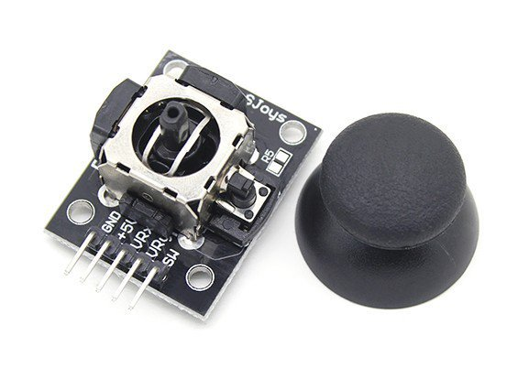

Components

Arduino

2. Joystick

3. Jumper Cables

4. USB Programming Cable for Arduino

Application

* It can be very handy for retro gaming, robot control or RC cars.
* Joysticks are also used for controlling machines such as cranes, trucks, underwater unmanned vehicles, wheelchairs, surveillance cameras, and [zero turning radius lawn mowers](https://en.wikipedia.org/wiki/Zero-turn_mower).
* Miniature finger-operated joysticks have been adopted as input devices for smaller electronic equipment such as [mobile phones](https://en.wikipedia.org/wiki/Mobile_phone)

**Objective**

During this activity ,you will help students to achieve following objectives

1. Understanding the principle and operation of Joy stick module

2. Design algorithm and flowchart for joystick using arduino

3. Programming Joystick module using Arduino uno

4. Interfacing Joystick module withArduino uno

**Programming**

int xVal;

int yVal;

void setup(){

  Serial.begin(9600);

  pinMode(A0,INPUT);

  pinMode(A2,INPUT);

}

void loop(){

  xVal = analogRead(A0);

  yVal = analogRead(A2);

  Serial.print("X = ");

  Serial.println(xVal);

  Serial.print("Y = ");

  Serial.println(yVal);

  delay(1000);

}

**Hardware**

**Instruction**

1. Connect Vcc and Gnd supply of Joystick module to the Arduino board power supply
2. Connect VRx and VRy pin to the analog input pin A0,A1of arduino

|  |  |  |
| --- | --- | --- |
| **Pin No.** | **Pin Name** | **Description** |
| 1 | Gnd | Ground terminal of Module |
| 2 | +5v | Positive supply terminal of Module |
| 3 | VRx | Voltage Proportional to X axis |
| 4 | VRy | Voltage Proportional to Y axis |
| 5 | SW | Switch |

